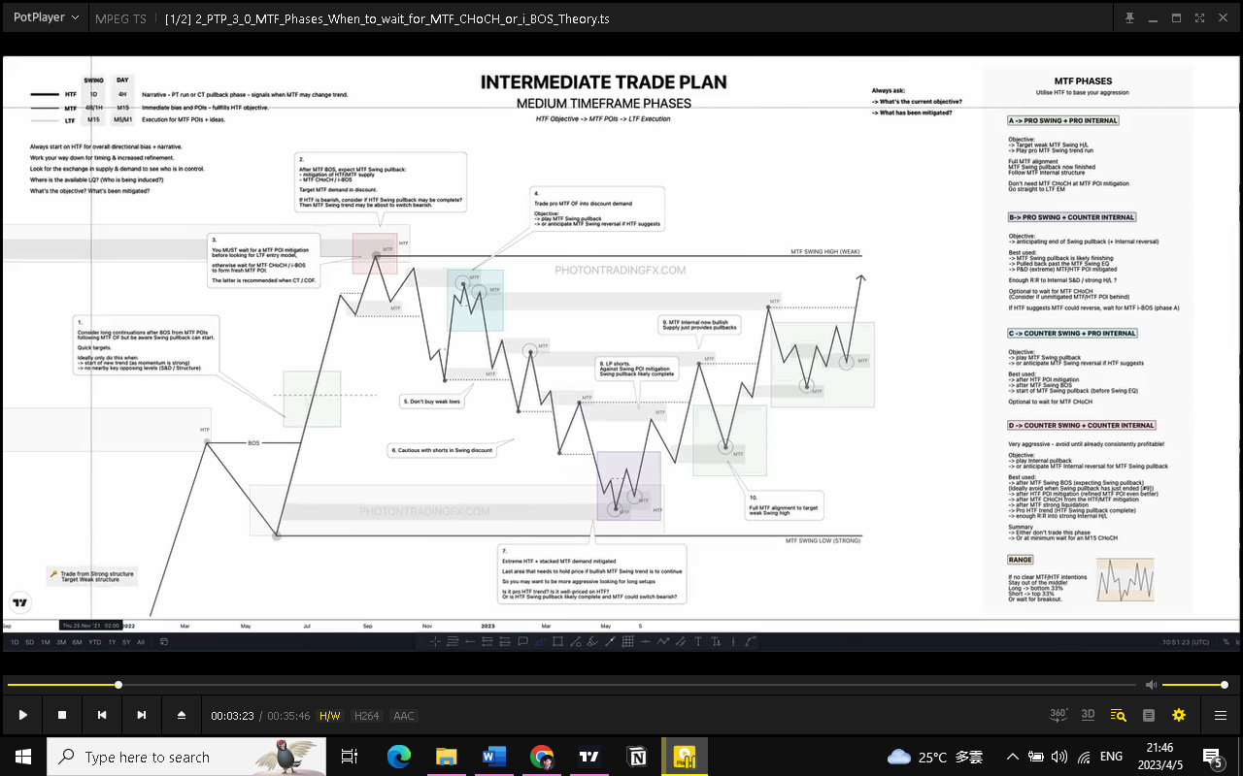
Aways Ask:
What is the current objective?
What has been mitigated?

Trade from Strong Structure
Target Weak Structure
9. MTF now bullish
Supply just provides pullbacks
10. Full MTF Alignment to target Weak Swing High
8. LP Shorts
Against Swing POI Mitigation
Swing pullback likely complete
7. Extreme HTF + Stacked MTF demand mitigated
Last area that needs to hold price if bullish HTF Swing Trend is to continue
So you may want to be more aggressive looking for long setups

Is it Pro HTF trend? Is It well-priced on HTF?
Or is HTF Swing Pullback likely complete and MTF could switch bearish?

Also look at HHTF if HTF is likely to turn.

6. Cautious with Count Swing in Swing discount
5. Don’t buy weak lows
Narrative – PT run or CT pullback phrase - signals when MTF may change trend
Immediate Bias and POIs – Fulfils HTF objective
Execution for MTF POIs + Ideas
4. Trade pro MTF into Discount Demand
Objective:
Play MTF Swing pullback
Or anticipate MTF Swing reversal if HTF suggests
3. You MUST wait for a MTF POI mitigation before looking for LTF entry model

Otherwise wait for MTF CH/iBos to form fresh MTF POI

The Latter is recommended when CT/COF
2. After MTF BOS expect MTF Swing pullback:
-Mitigation of HTF Supply
-HTF CH/iBos
Target HTF Demand in Discount

If HTF is bear, consider if HTF Swing pullback complete?
Then MTF Swing Trend may be about to switch bearish
1. Consider long confirmations after BOS from MTF POIs
following MTF OF But beware Swing Pullback can start

Quick Targets

Ideally only do this when:
-Start of new trend (momentum is strong)
-No nearby key opposing levels (S&D, Structure)
Always Start on HTF for overall Bias + narrative
Work your way down for timing and Increased Refinement
Look for the exchange in S&D to see who is in control
Where is the available LQ? (Who is being induced?)
What’s the objective? What’s been mitigated?
APRO SWING + PRO INTERNAL
Objective:
Target Weak MTF Swing HL
Play Pro MTF Swing Trend Run
Full MTF Alignment
MTF Swing Pullback now Finished
Follow MTF Internal Structure
Don’t need MTF CH at MTF POI Mitigation
Go straight to LTF Entry Model
BPRO SWING + COUNTER INTERNAL
Objective:
Anticipating end of Swing Pullback (+internal reversal)
Best used:
MTF Swing pullback is likely finishing
Pulled back past the MTF Swing EQ
P&D (extreme) MTF/HTF POI Mitigated
Enough R:R to internal S&D/ Strong H/L?
Optional to wait for MTF CH
(Consider if unmitigated MTF/HTF POI behind)
If HTF suggest MTF could reverse, wait for MTF iBOS (phrase A)

DCOUNTER SWING + COUNTER INTERNAL
VERY AGGRESSIVE – avoid until already consistently profitable!
Objective:
Play Internal pullback
or anticipate MTF internal reversal for MTF Swing Pullback
Best used:
after MTF Swing BOS (expecting a Swing pullback)
(ideally avoid when Swing pullback has ended #9)
after MTF POI mitigation (refined MTF POI even better)
start of MTF CH from HTF/MTF mitigation
after MTF strong liquidation
Pro HTF trend (HTF Swing pullback complete)
enough R:R into strong internal H/L
Summary
Either don’t trade this phrase
Or at minimum wait for M15 CH

C COUNTER SWING + PRO INTERNAL
Objective:
Play MTF Swing Pullback
or anticipate MTF Swing reversal if HTF Suggests
Best used:
after HTF POI mitigation
after MTF Swing BOS
start of MTF Swing pullback (before Swing EQ)
Optional to wait for MTF CH

Range
If no clear MTF/HTF intentions
Stay out of the middle!
Long bottom 33%
ShortTop 33%
Or wait for breakout

